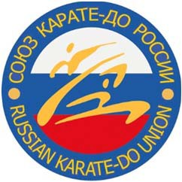 | ALL-RUSSIAN SPORTS PUBLIC ORGANIZATION  "RUSSIAN KARATE-DO UNION"  125284, Moscow, st. Polikarpova 3-A  tel. +7-925-991-61-72  e-mail: president@karate-union.ru  www.karate-union.ru  reg# 1117799006808

Moscow

12°TH WORLD KARATE CHAMPIONSHIP FOR CLUBS
Velletri (Rome), 30th – 31st January 2016

R E Z A L T S
№ | Name, Lastname | Sex | date of Birth | age | Grade\  class | Style | Kata | Kumite
1 | NAZAROV VIKTOR | M | 09.08.05 | 10 | 2 Kyu | shoto | + II | -
2 | YAKOVLEV ARTEMIY | M | 17.01.08 | 8 | 9 Kyu | shoto | + II | -
3 | ZINOVIEV SERGEY | M | 23.01.09 | 7 | 9 Kyu | shoto | + I | -
4 | LEONOVA ANASTASIA | F | 12.06.03 | 12 | 3 Kyu | - | - | I +47, Nihon
5 | IVANTSOVA ELENA | F | 26.07.05 | 10 | 1 Dan | shoto | + I | -

